Water Is Water

Focus Question
How are the animals that live in the ocean different than the animals that live in a swamp? Why are the kinds of animals so different if they both live in water?

Activity Synopsis
Students observe the Great Ocean Tank and Blackwater Swamp exhibits in the S.C. Aquarium. Students group organisms according to habitat and determine why the habitats are so different.

Time Frame
1 hour

Student Key Terms
- swamp
- ocean
- fresh water

salt water
- salinity
- adaptation
- physiological

Objectives
The learner will be able to:
- Group animals according to habitat and observe the differences between the two habitats.

Second Grade Standards Addressed

Science Standards
IA1a, IA4a, IB1a, IB1c, IIA2a, IIA2b

Background

Key Points
Key Points will give you the main information you should know to teach the activity.

- Blackwater swamps are a type of freshwater wetland.
- The salty ocean water covers nearly 70% of the Earth’s surface.
- With a few exceptions (such as salon and striped bass), salt water organisms cannot live in fresh water habitats and vice versa. Organisms in each habitat have adapted physiological responses to their particular surroundings.

Detailed Information
Detailed Information gives more in-depth background to increase your own knowledge, in case you want to expand upon the activity or you are asked detailed questions by students.

(Information from http://www.epa.gov/owow/wetlands/types/swamp.html)
A swamp is defined as a wetland that is dominated by woody plants. This is in comparison to a salt marsh, for example, that is dominated by the perennial grass, Spartina. The types of swamps vary. For example, in the Northeast, red maple swamps are most common, whereas in the Southeast, we have the familiar bottomland hardwood forests. These swamps are located along the slow-moving rivers of the Coastal Plain.

Two important characteristics of swamps are (1) saturated soils during the growing season, and (2) standing water during certain times of year. The soils in swamps are highly organic and form a thick, dark, nutrient-rich environment that supports the growth of water-tolerant trees. Examples of water-tolerant trees are cypress, Atlantic white cedar, and tupelo. Frequently, these trees will buttress, or swell, at the base of their trunks due to the saturated soil condition. It is theorized that this helps to support the tree as well as to help the tree take in oxygen from the air. Cypress trees actually grow “knees”, which are woody extensions of the plant that project above the ground. Rather than trees, some swamps are predominantly vegetated by shrubs. In fact, swamps may be separated into two types: shrub swamps and forested swamps. Forested swamps are inundated with floodwater from nearby rivers and streams. Several feet of slow moving or standing water often cover them. During a drought, these swampy areas may be the only fresh, shallow water for many miles and their presence becomes critical to the survival of species such as the wood duck, the river otter, the cottonmouth snake, and many other species. The forested swamps in our area are frequently called bottomland hardwood swamps. In South Carolina, the Francis Beidler Forest in Four Holes Swamp contains the largest remaining virgin stand of tupelo gum and bald cypress trees in the world. The area is protected by the National Audubon Society. Shrub swamps are dominated by shrubby vegetation such as buttonbush, dogwood, and swamp rose. These may be found adjacent to a forested swamp. This swamp is found along slow moving streams and in floodplains and is therefore covered by water for much of the year. The mangrove swamps of southern Florida are an example of a shrub swamp.

Both types provide valuable habitat for wildlife. In addition to being critical habitat for wildlife, swamps provide flood protection and nutrient removal. Flooding adds rich deposits of alluvial soil to the swamp forests. This creates an ecosystem high in productivity and rich with biodiversity. Due to the fertility of the soil, many of these areas have been drained and cleared for agricultural purposes. More than 70% of the country’s forested floodplain swamps have been destroyed. The historical portrayal of the swamp as a frightening, dismal place also led to the destruction of many tracts of swampland over the last 200 years.

Bald cypress, tupelo and black gum trees dominate the black-water swamps of the South Carolina coastal plain. The black water is not polluted, rather the water appears black due to the tannic acid in the bark and leaf litter on the swamp floor.
Ocean:
Over 71% of the Earth’s surface is covered with water, and, 98% of that water is oceanic salt water. Oceanic water is ultimately the source of fresh water on land. The ocean water is cycled onto the land’s surface through the hydrologic cycle. The global ocean is divided into the Atlantic, Pacific, Indian and Arctic Ocean Basins. Although each of these bodies of water is connected, they differ enough to be considered separate bodies of water. The coastline of the Southeastern United States abuts the western edge of the Atlantic Ocean. The Atlantic Ocean is a highly productive body of water and has abundant marine life. The greenish-blue hue of our coastal water gives us a hint of the high productivity in the Atlantic Ocean!

Procedures:

Materials
- Data Sheet (one copy per student)
- Clipboards
- Pencils

Procedure
- Lead the students to the Great Ocean Tank exhibit. Tell the students to look around the tank and tell you what they see. Have the students label the left side of the Venn diagram “Ocean”. Ask the students if they see any of the organisms that are pictured on the bottom of their data sheet. Have them draw a line from the organism to the “Ocean” bubble. The students should locate the Pork Fish (look around the coral reef area), the Loggerhead Turtle (look toward the top of the tank, the Loggerhead must breathe air), and the shark (there are a few different species of sharks in the tank – this is usually not a problem for children to locate).
- After the students have drawn lines from the organisms to the ocean bubble, ask the students to draw a picture of what they see in the ocean tank. (Optional: There is a bleacher-type sitting area in the ocean gallery. You may choose to allow the students to sit here and color the picture with crayons.) Prompt the students to pay careful attention to the things in the tank that are not moving! Do they see any plants? What colors do they see?
- Move the students upstairs into the Blackwater Swamp exhibit. Again, ask the students to tell you what they see in the swamp. Have students label the right side of the Venn diagram “Swamp” and prompt them to locate the animals pictured at the bottom of the page. Note: the alligators are located in the exhibit hall, but not in the actual swamp exhibit. Note to students that the entire area is representative of a swampy area.
- After the students have matched the animals to the correct habitat, ask the students to draw a picture of what they see in the exhibit. Have them pay particular attention to how deep the water is in this exhibit vs. the ocean tank, the vegetation present, color of the water, the colors they observe, etc.
- You may choose to move the students back to the sitting area in front of the Great Ocean Tank. Ask the students to look at their pictures and tell you what is the same in both pictures. Have them write those words, or draw the pictures in the center bubble of the Venn diagram. For example, students may note that both habitats contain water (if they do not recognize this prompt them to make that observation) and that both habitats have animals, even though they are different animals.
- Prompt the students to make further observations. Pay attention to the size of the animals. Which was bigger, the soft-shelled turtle or the Loggerhead turtle? The shark or the gar? Where did you see a brightly colored fish?
- Ask the students the following question: if both habitats have water, and the animals in those habitats live in the water, then why do the animals look so different? Is the water the same? When you go to the beach and get splashed in the face by a wave, how does the water taste? Does it taste the same as in a swimming pool, or in a lake? Why not? Lead the students to the conclusion that the habitats differ in that one is saltwater and one is fresh water.
- Tell the students to look again at the exhibits (or their drawings). If they see brightly colored corals, then they are looking at salt water. Have them label the Ocean side as “salt”. If they see trees with knees, then they are looking at fresh water. Have them label the swamp as “fresh”.
- Explain to the students that the ocean has a lot more living space, so the animals in the ocean can grow larger. It is actually better to grow larger because then you will not have many natural predators. What would happen if we put a fresh water fish into the ocean? If you accidentally swallow too much ocean water, how do you feel? A little sick? The animals in the swamp are just like us, the salt water will make them sick. And, the animals that live in the saltwater would get sick in the fresh water!

Assessment:
Back in the classroom, show the students a picture of the Lookdown (fish). This can be found on the CD-ROM that accompanies the activity guide. Tell the students to look at their data sheet from the Aquarium. The Lookdown needs salt water. Would it live in the ocean or the swamp? Who might live with the Lookdown? Have the student write 2-3 sentences to answer these questions.
Mastery/Nonmastery: The student correctly groups the Lookdown according to habitat. Using his/her data sheet, the student correctly identifies other animals in the saltwater habitat.

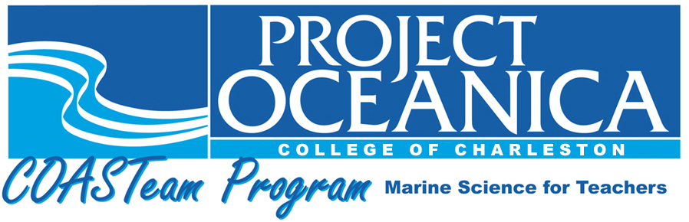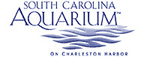

Members of the COASTeam Aquatic Workshops development team include: Katrina Bryan, Jennifer Jolly Clair, Stacia Fletcher, Kevin Kurtz, Carmelina Livingston, and Stephen Schabel.
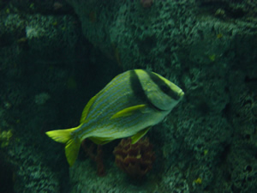
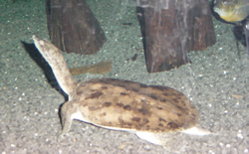
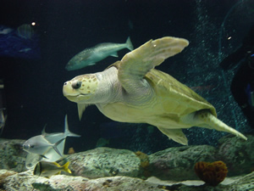
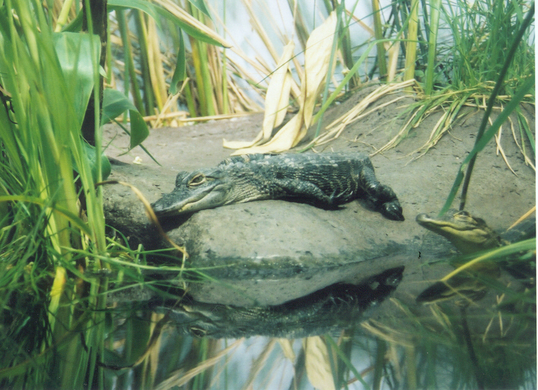
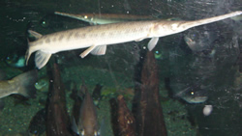
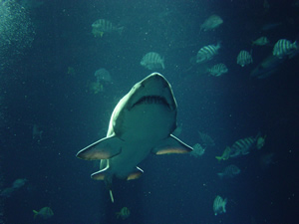
Pork Fish
Soft Shelled Turtle
Loggerhead Turtle
American Alligator

Long Nosed Gar Fish
Shark
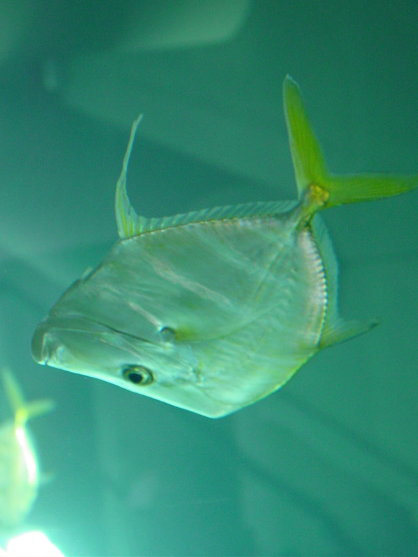

Lookdown
Photo by Will Sautter

